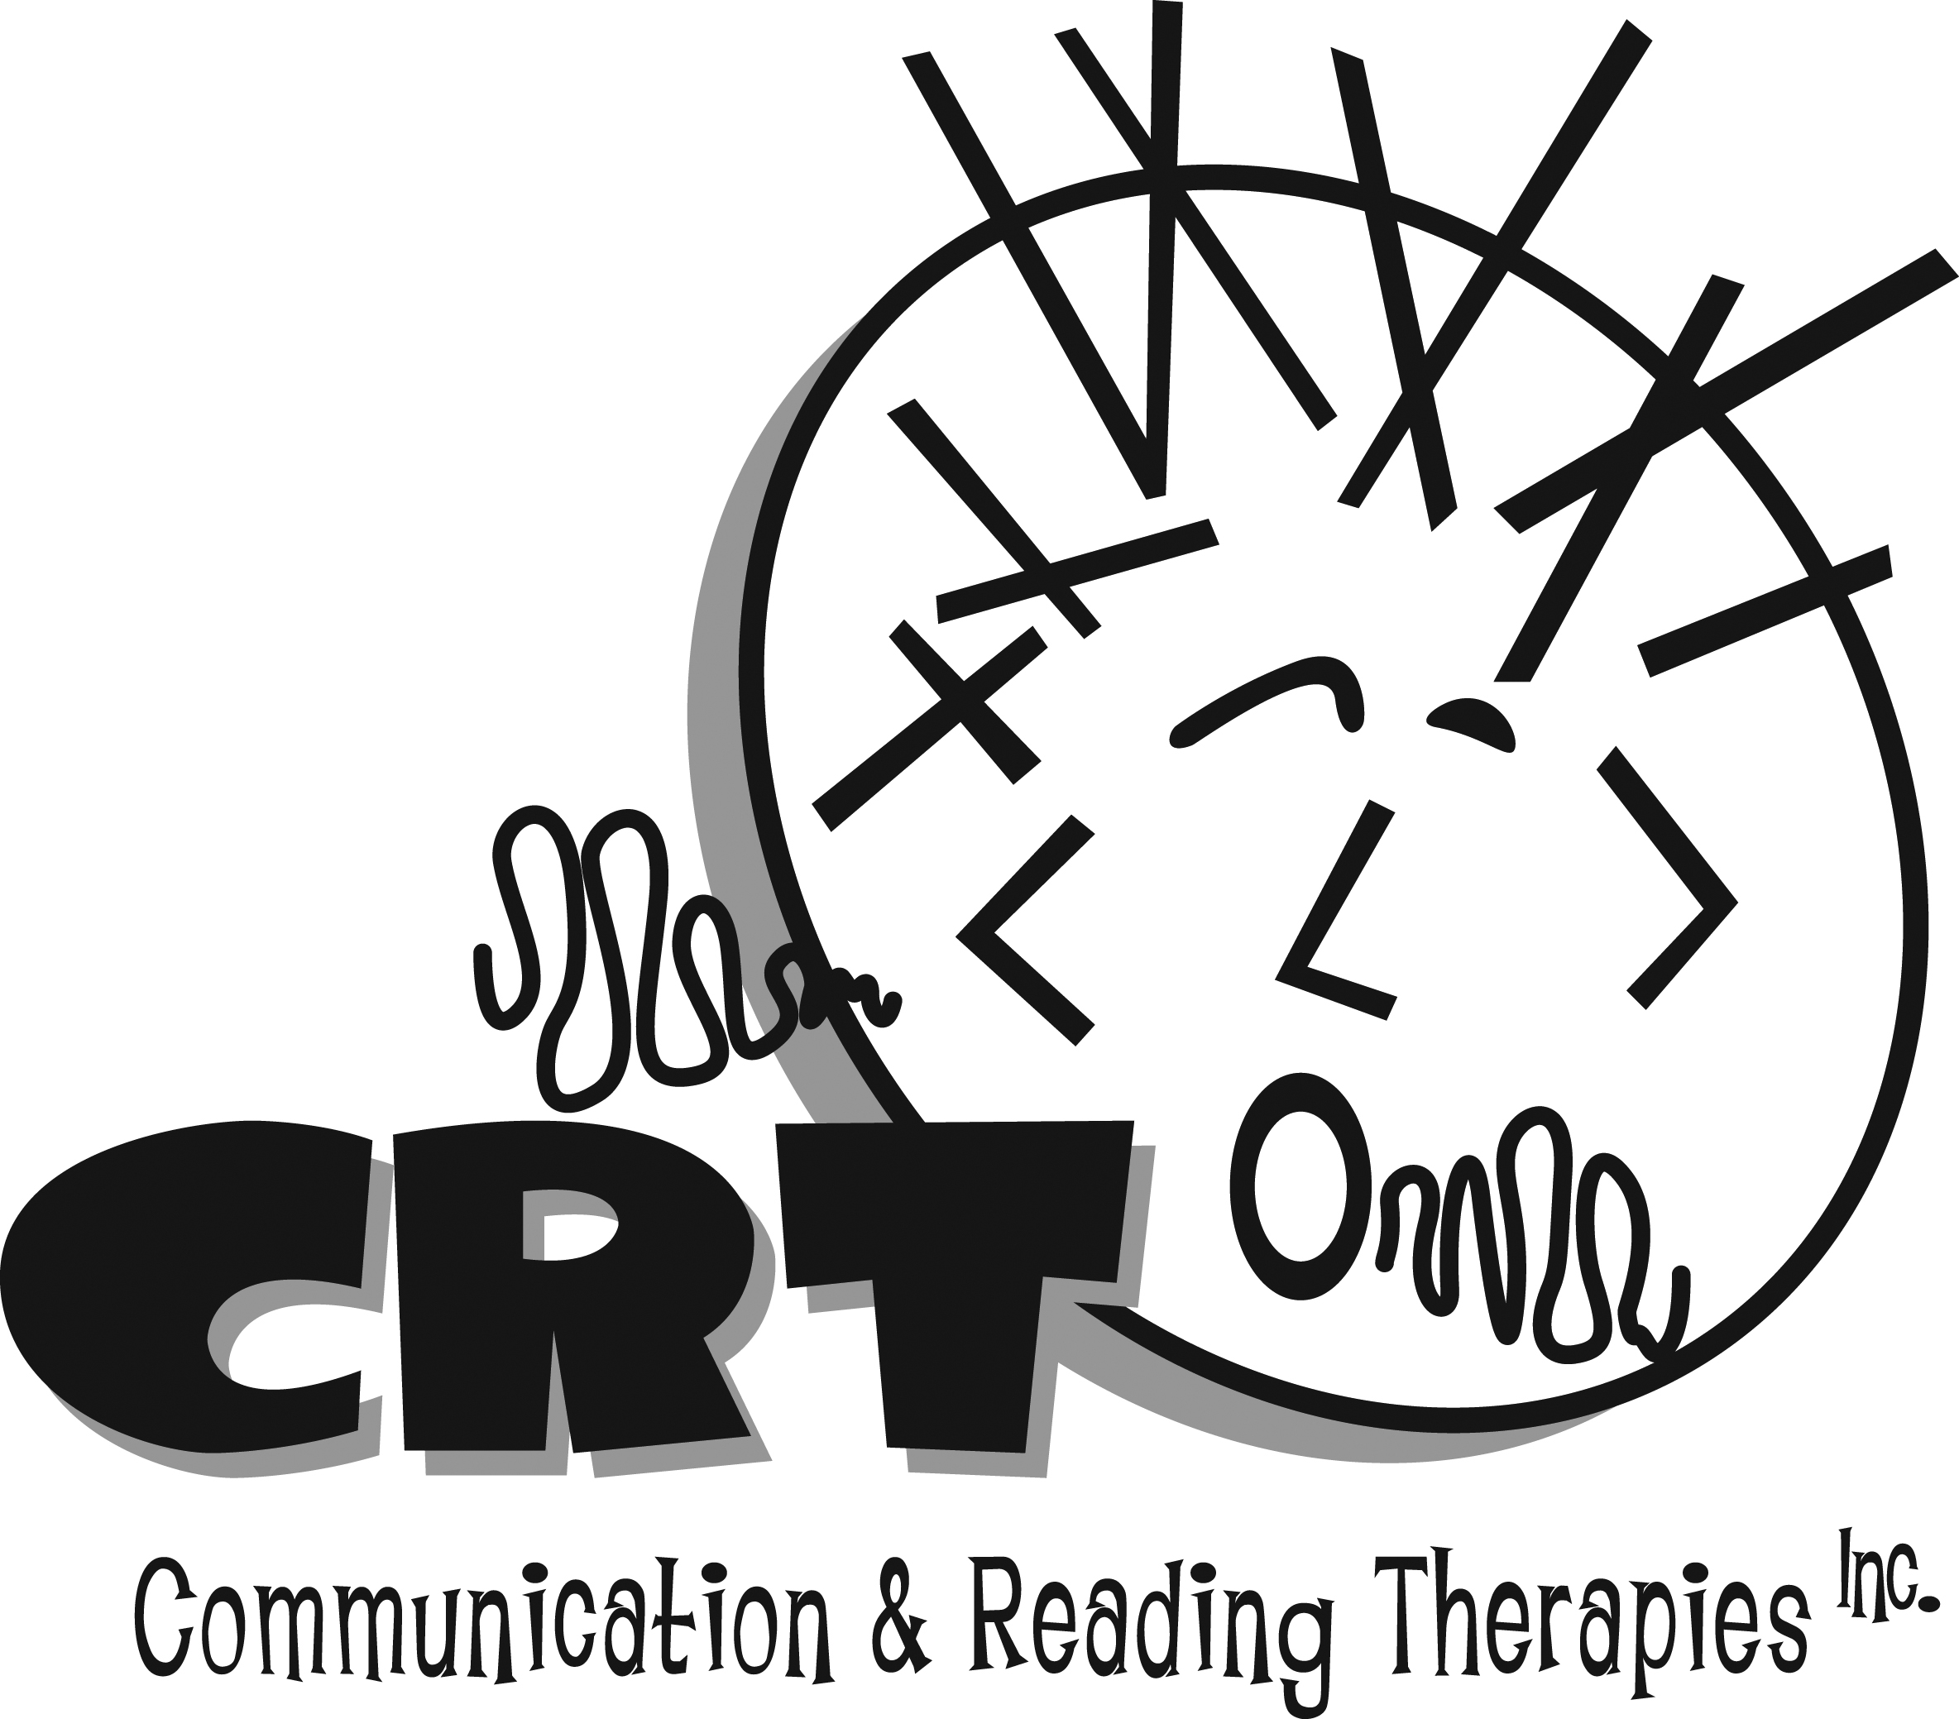
www.communicationandreading.com
Speech-Language Pathologists
300 Vestavia Parkway, Suite 2300
Birmingham, AL 35216
(205) 919-0955
info@communicationandreading.com

Client’s Name:_____________________________ Age:___________________

Address:____________________________ DOB:__________________

_____________________________ School:__________________

Home Phone:____________________ Cell:_____________Work:_____________

E-mail:_____________________________ Grade :___________________

Parents:_______________________________ Teacher:___________________

Referred by:____________________________ Pediatrician: _________________

Preferred Contact Method:_________________ Employer:__________________

Concerns:______________________________________________________________

Does your insurance cover speech/language services? ___________ If yes, insurance

provider:_____________________________

Policy #___________________________

# of visits per year:__________________

I, the undersigned, do hereby agree and obligate myself to pay the balance due in consideration for the services rendered by Communication and Reading Therapies. I understand that all fees are to be paid within thirty days of invoice receipt. Filing a claim with a third party reimbursement source shall not relieve me of my obligation to pay for all services rendered. I hereby agree to pay all expenses of collecting unpaid statements, including all attorney’s fees and court costs. I further understand that a late fee of $25 may be charged on an unpaid balance after thirty days.

____________________________ ________________________ ___________ Responsible Party Relationship to Client Date

