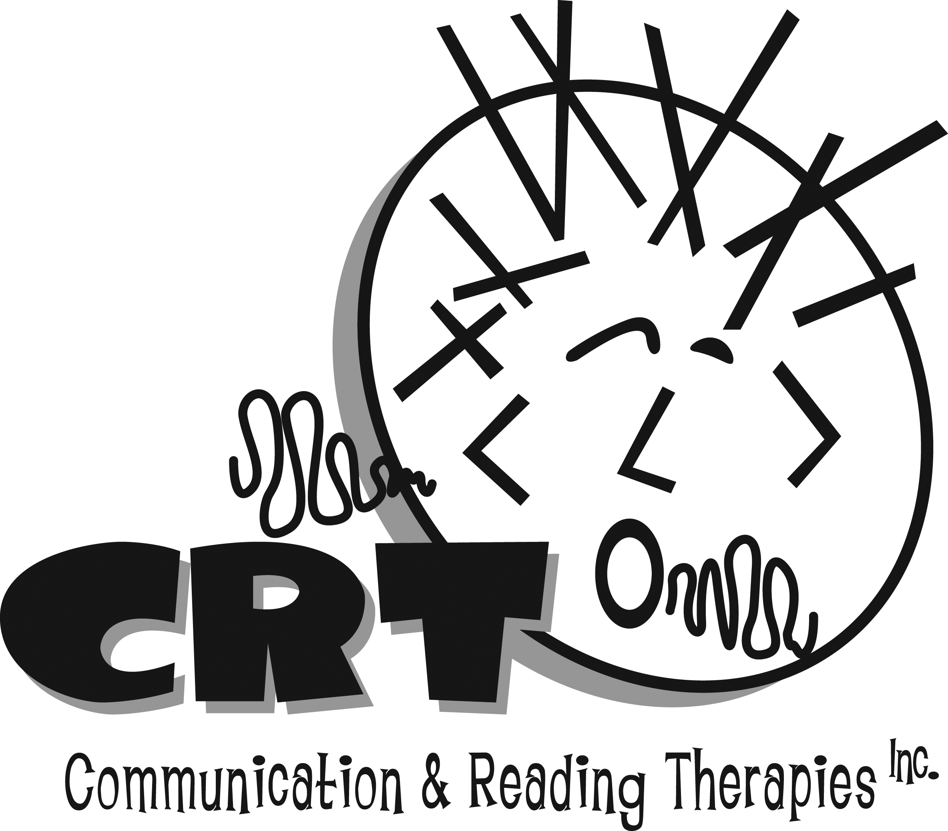
www.communicationandreading.com
Speech-Language Pathologists
300 Vestavia Parkway, Suite 2300
Birmingham, AL 35216
(205) 919-0955

CRT is dedicated to providing quality services. This quality service depends on timely payment of invoices by you the customer. CRT will work with any family who experiences financial difficulties while a child is receiving services.

- Evaluation charges are due at the time of the evaluation. Statements for treatment services rendered are e-mailed the last week of each month. Payment is due upon receipt or no later than the 15th day of the following month.

- Evaluation reports will be e-mailed within seven business days of the evaluation.

- If the payment for services is not received by the 30th of the month, the account will be charged a late fee of $20.00 which will appear on the next statement.

- If the account is 60 days past due, the account must be paid in full or services may be discontinued.

- Any account whose check is returned for insufficient funds will be charged a fee of $25.00.

- We are Blue Cross / Blue Shield out-of-network providers. Clients are responsible for seeking reimbursement from insurance companies by filing claims if accepted.

- Clients are asked to cancel at least 24 hours in advance. Clients will be billed half of the fee for scheduled sessions that are cancelled without notice.

